



**Disclaimer: The content is curated from online/offline resources and used for educational purpose only**

**LAB MANUAL**

**Unit I – Foundation of Green Skilling, Sustainability and AI Contributions**

**Unit I – Foundation of Green Skilling, Sustainability and AI Contributions**

**Lab - 2**

Swachh Bharat Mission (Waste Management)

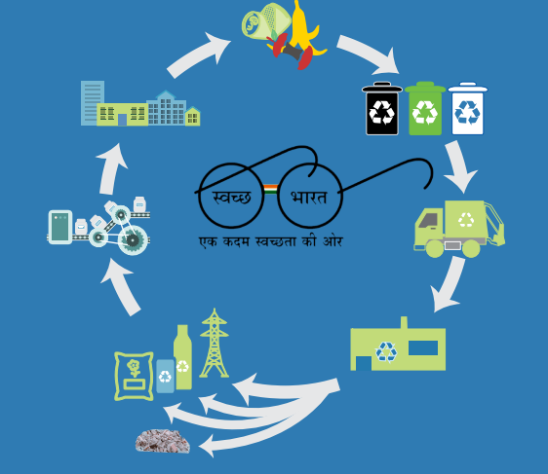

https://encrypted-tbn1.gstatic.com/images?q=tbn:ANd9GcSTEezObO9CYH6OePeTZvoisQcouUX0xGwcjH8rH9Kzc546POgd

**About SBM**

The Swachh Bharat Mission was launched by Prime Minister, Mr. Narendra Modi on October 2, 2014, to sharpen the focus on hygiene, and help the country achieve universal sanitation. The first phase of the mission has been performed as a national campaign, to overcome open defecation in rural areas through mass-scale behavior change, construction of household-owned and community-owned toilets, and implementing techniques for monitoring toilet construction & usage from 2014 to 2019. SBM-U is launched on 1st October 2021 for 5 years. SBM-U 2.0 will envision "Garbage Free" cities for all by the year 2026.

**The objectives of the mission are mentioned below:**

* All households and premises are segregating their waste into "wet waste" from the kitchen and gardens, and "dry waste," which includes paper, glass, plastic, as well as domestic hazardous and sanitary waste kept separately.
* 100% collection of door to door from each household/premise segregated waste.
* 100% scientific management of all the fractions of waste, including safe disposal in scientific landfills.
* All legacy dumpsites remediated and converted into a green zone.
* All used water, especially fecal sludge, in small cities is safely collected, transported, treated, and disposed of in such a manner that no untreated fecal sludge and used water contaminates the ground or water bodies.

**The Mission has the following components:**

* Household toilets, including conversion of insanitary latrines into pour-flush latrines;
* Community toilets
* Public toilets
* Solid waste management
* IEC & Public Awareness
* Capacity building and Administrative & Office Expenses (A&OE)

Swachh Bharat Mission: Nirmal Bharat Abhiyan was merged with Swachh Bharat Mission. Under the mission, a National Scheme Sanctioning Committee (NSSC) is constituted for specific time durations to sanction or amend the action plans. Implementations were tagged at the national, state, district, block, and village levels.

The National Scheme Sanctioning Committee comprises the following:

* Secretary, Ministry of Drinking Water and Sanitation – Chairperson
* Additional Secretary & Financial Advisor, Ministry of Drinking Water & Sanitation
* Secretary in-charge of Rural Sanitation of the State (whose proposal is to be considered)
* Joint Secretary in-charge of Sanitation, Ministry of Drinking Water and Sanitation
* Two experts on rural sanitation (as nominated by the chairperson)

**Phase I:**

**The objectives in this phase of the Swachh Bharat Mission were as follows:**

* Improve the general quality of life in rural areas by promoting cleanliness and hygiene and abolishing open defecation.
* Sanitize the rural areas with accelerated coverage for total implementation by October 2, 2019.
* Health education among the communities and Panchayati Raj institutions should create awareness about adopting sanitation practices and facilities sustainably.

* Promote cost-effective and appropriate technologies that are ecologically safe and sustainable in sanitation.

* Implement community-managed sanitation systems wherever needed with focus on scientific Solid & Liquid Waste Management systems to achieve collective hygiene in rural areas.

* Create significant positive effect on the gender dimension and social inclusion by improving sanitation that focuses on mainstreaming general marginalized communities.

**Phase II**

With the successful culmination of Phase-1, the central government has sanctioned Phase-II of the programme to bring sanitation and hygiene status in rural areas. The mission will be implemented between 2020-21 and 2024-25 with an estimated total outlay of Rs. 1,40,881 crore (US$ 19.11 billion). Focus will remain on sustainability of Open Defecation-Free status and solid & liquid waste management.

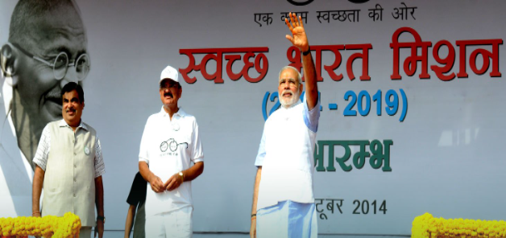

https://sulabhenvis.nic.in/WriteReadData/UserFiles/banner1.jpg

Objectives of the second phase of Swachh Bharat Mission are as follows:

* Open Defecation-free Sustainability: Access to toilets in the village, elementary schools, panchayat ghars, and Anganwadi centers. In addition, at least five IEC messages on specified themes must be displayed in the villages. A community sanitary complex should be provided where the village has more than 100 households.
* It includes effective management of solid wastes by at least 80% of household and public places by the management of biodegradable wastes from cattle and agricultural activities by individual and community compost pit-an adequate segregation and community system of plastic waste.
* Liquid Waste Management: It involves the proper management of liquid waste by at least 80% of households and public places; and, grey water generated from kitchen use and bathing, storm water from individual and community soak pits and black water due to overflow from septic tanks.
* Visual Cleanliness The village shall be rated as visually clean if 80% of houses and all public places are found to have minimum litter and stagnant water with no dumping and no accumulation of plastic waste.

**Swachh Bharat Mission: Urban Areas**

The scheme is going to cater for 1.04 crores of households, to construct 2.5 lakh community toilets, 2.6 lakh public toilets and a facility for solid waste management in each town. Community toilets will be constructed as an alternative under the scheme in residential areas, where it is difficult to construct individual household toilets. Similarly, public toilets will also be constructed in specified places like tourist destinations, markets, bus stands, railway stations, etc. The programme will be carried out over five years in 4,401 towns. Out of the Rs 62,009 crore likely to be spent on the programme, the Centre will pitch in Rs 14,623 crore. Of the Centre's share of Rs 14,623 crore, Rs 7,366 crore will be spent on solid waste management, Rs 4,165 crore on individual household toilets, Rs 1,828 crore on public awareness and Rs 655 crore on community toilets.

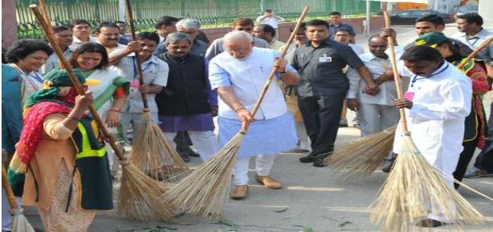

<https://sulabhenvis.nic.in/WriteReadData/UserFiles/02-modi-swachh-bharat.jpg>

The programme includes elimination of open defecation, conversion of unsanitary toilets to pour flush toilets, eradication of manual scavenging, municipal solid waste management and bringing about a behavioural change in people regarding healthy sanitation practices.

**Swachh Bharat Mission: Gramin Areas**

Swachh Bharat Abhiyan is the reformatted version of the Nirmal Bharat Abhiyan. The mission aims to make India an open defecation free country in Five Years. And under the mission, One lakh thirty four thousand crore rupees will be spent on construction of about 11 crore 11 lakh toilets in the country". It would deploy technology in large scale conversion of waste into wealth in rural India in forms of bio-fertilizer and different forms of energy. It was to be executed on a war footing with the participation of each and every gram panchayat, panchayat samiti and Zila Parishad throughout the country along with large sections of rural population and the school teachers and students.

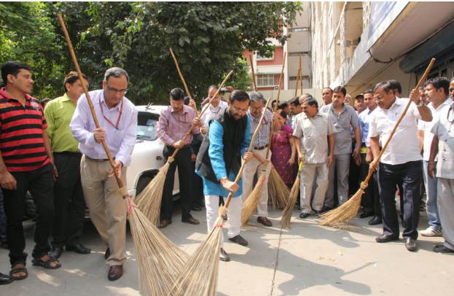

As part of the mission, for rural households, the provision for unit cost of individual household latrine has been increased from Rs 10,000 to Rs 12,000 so as to provide for water availability, including for storing, hand-washing and cleaning of toilets. Central share for such latrines will be Rs 9,000 while state share will be Rs 3,000. Therefore, the Central share for North Eastern states, Jammu & Kashmir, and special category states, would be Rs 10,800 and the state share Rs 1,200. The increments from other sources are also likely to be allowed.

**Swachh Bharat Mission – Key Developments**

* In March 2023, the President launched "Jal Shakti Abhiyan: catch the rain"- 2023 with the theme "source sustainability for drinking water".
* In October 2022, Telangana topped the list of the large states category of Swachh Survekshan Grameen (SSG) 2022, which gauges the sanitation scenario in villages. Haryana held the second position, while Tamil Nadu ranked third.
* Launched in February 2021, Swachh Bharat 2.0 is designed with a view to comprehensive faecal sludge management. In addition to this, wastewater treatment, garbage segregation, minimization of single-use plastics, minimization of air pollution through waste management from construction sites and demolition processes, and bioremediation of all legacy dump sites will be considered.
* The government has announced construction of >7 million toilets in urban areas and several transformative initiatives have been undertaken.

* In December 2020, the government has launched the 'Swachhata Abhiyan', a mobile application developed to identify and geotag insanitary latrines and manual scavengers so that these can be replaced with sanitary latrines and manual scavengers rehabilitated to provide dignity of life to them.

* The government had launched 'Swachh Bharat Mission Academy' in August 2020, which is an IVR-based training module having modules on the Open Defecation Free Plus programme.

* The government has already announced the completion of Rashtriya Swachhata Kendra in August 2020-an experiential visitor centre designed to educate citizens on the 'Swachh Bharat Mission'. Both digital and outdoor installations, placed here to educate, disseminate, and heighten awareness on the importance of cleanliness and related aspects, will be offered.

**Swachh Bharat Mission – Key Investments**

* While presenting the interim budget for 2024-25, the Ministry of Jal Shakti received an allocation of Rs. 98,418 crore or US$ 11.80 billion, with 71% to go to its flagship Jal Jeevan Mission. The said allocation surpasses last year's budget for the ministry, wherein it had been allocated Rs. 96,549 crore or US$ 11.58 billion.
* The government has sanctioned Rs. 1,41,678 crore (US$ 19.22 billion) for the next five years to handle water, land & air pollution in addition to waste management during February 2021.
* The National Bank for Agriculture & Rural Development (NABARD) has released Rs. 12,298 crore (US$ 1.66 billion) of Swachh Bharat Mission Gramin (SBM-G) funds for building 32.9 million toilets in the household sector as on October 2020.

* In February 2020, the government allocated Rs. 12,300 crore (US$ 1.69 billion) for Swachh Bharat.

* In December 2019, 73 central public-sector enterprises (CPSEs) were nudged by their administrative department – the Department of Public Enterprises (DPE) – to spend over Rs. 1,000 crore (US$ 135.70 million) towards the Swachh Bharat Mission.

**Conclusion**

The Toilet Board Coalition estimates that the sanitation economy-for those in the dark, it refers to a buoyant marketplace of products and services, renewable resource flows, data and information which is sustainable, innovative, cost saving and revenue generating-of India stood at US$ 62 billion in 2021. The Swachh Bharat Mission is a revolutionary change in the country's sanitation drive. This flagship movement increased the demand several times more for the construction and usage of toilets. It, furthermore opened various windows of opportunity for stakeholders as well as sanitary market participants.

**Reference**

1. <https://www.ibef.org/government-schemes/swachh-bharat-mission>
2. https://sulabhenvis.nic.in/Database/SwachhBharatAbhiyan_7101.aspx?format=Print